*For the sensitivity analysis, I use 20 repetitions and let the model stop after 3500 ticks. The initial setting of the model is 300 persons, 90 co-farmers, village size of 10, 4 rangers, coop-benefit of 100 and max-debt-level of -670.*

* Number of co-farmers

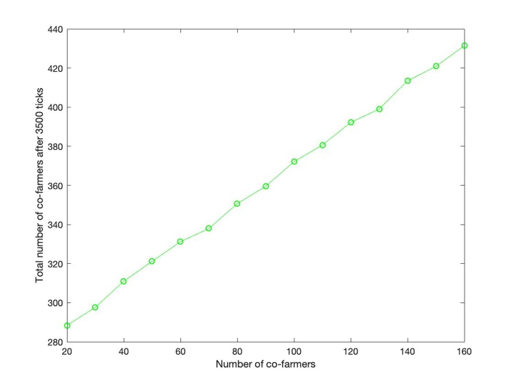

* Max-debt-level

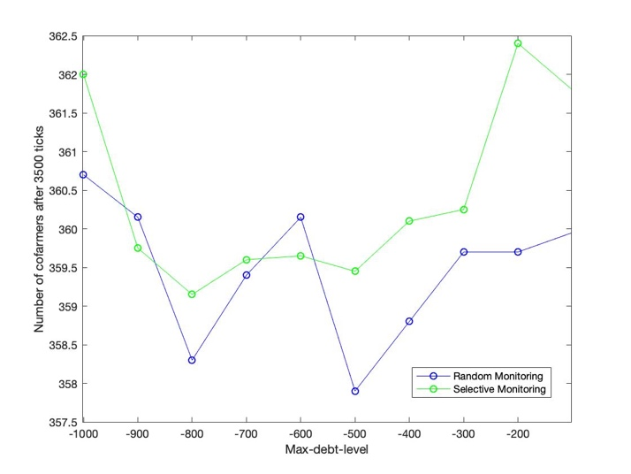

* Coop-benefit

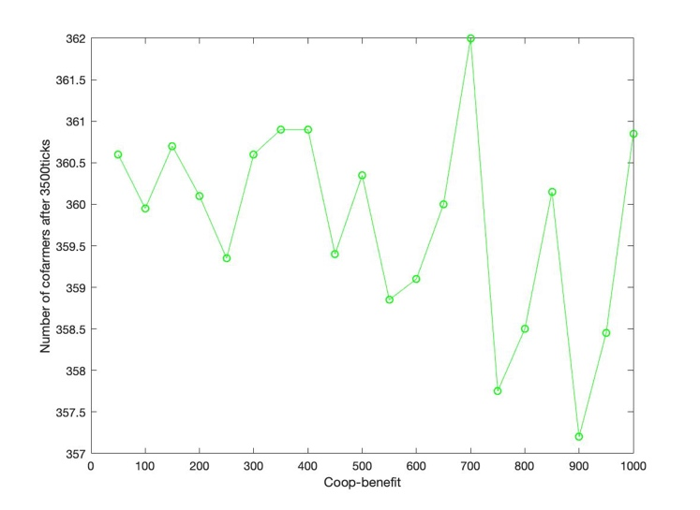

* Number of rangers

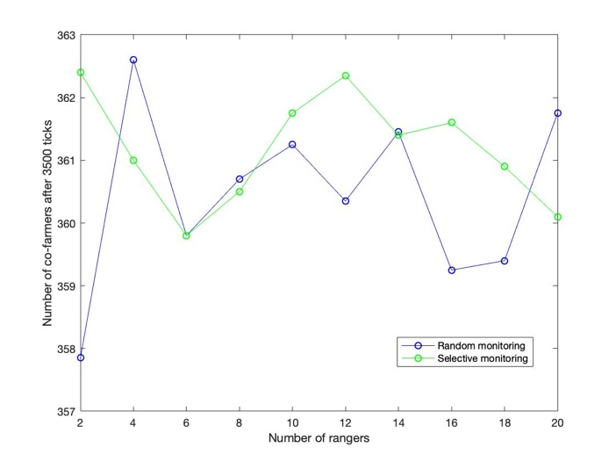

* Village size

